INSTAGRAM SAMPLES

THANK YOU for making a difference in the fight against cancer at the University of Wisconsin! Whether you are walking, running or biking, The Ride provides an exhilarating day of fun and meaning to those affected by cancer. However, THE RIDE IS MORE THAN JUST AN EVENT in September. It is a year-round campaign that is accelerating cancer research at the University of Wisconsin.

This document serves as a RESOURCE OF INSTAGRAM POST TEMPLATES representing participants at all levels of fundraising ambition. Whether your primary goal is to maximize dollars raised for cancer research or simply share your involvement in raising awareness, we applaud your effort in accelerating the brightest cancer minds, ideas and technologies at the University of Wisconsin.

Would you like to help others by submitting a sample to be included in this document? Please send samples and fundraising best practices to hello@TheRideUW.org.

STEPS TO SUCCESS
The MOST IMPORTANT ROLE you have in contributing to the UW cancer mission is to share your Ride journey.
Take a moment and determine your WHY and your level of AMBITION to accelerate our critical lifesaving efforts being developed today at the UW Carbone Cancer Center.
WHY are you walking, running or biking at The Ride?
What is your AMBITION in sharing your motivation with others? Are you looking to drive fundraising dollars to the cancer mission or simply share your involvement at The Ride?

A Benefit for Cancer Research at the University of Wisconsin
RAISED HERE. STAYS HERE.
TheRideUW.org

TABLE OF CONTENTS
The goal of this document is to provide a fluid resource for participants in utilizing and contributing email templates that share participants’ involvement and provide contribution opportunities.

MESSAGING OPPORTUNITY: AT THE TIME OF REGISTRATION
SAMPLE 1 FUNDRAISING ASK #1……….……………………………………..pp 3
SAMPLE 2 FUNDRAISING ASK #2…….………………………………………..pp 3
SAMPLE 3 JOIN MY FUNDRAISING TEAM #1…….………………...……..…..pp 4
SAMPLE 4 JOIN MY CORPORATE TEAM #1…….…………...……...……..…..pp 4
MESSAGING OPPORTUNITY: INVITE OTHERS
SAMPLE 1 JOIN ME AT THE RIDE #1…….……………………...……………..pp 5
SAMPLE 2 JOIN ME AT THE RIDE #2…….……………………...……………..pp 5

MESSAGING OPPORTUNITY: BIRTHDAY GIFT DONATION
COMING SOON!

MESSAGING OPPORTUNITY: MIDWAY THROUGHOUT CAMPAIGN
COMING SOON!

MESSAGING OPPORTUNITY: POST-EVENT
COMING IN AUGUST!

MESSAGING OPPORTUNITY: ANNUAL CAMPAIGN RESULTS
COMING IN OCTOBER!

AT THE TIME OF REGISTRATION, SAMPLE 1
FUNDRAISING ASK #1
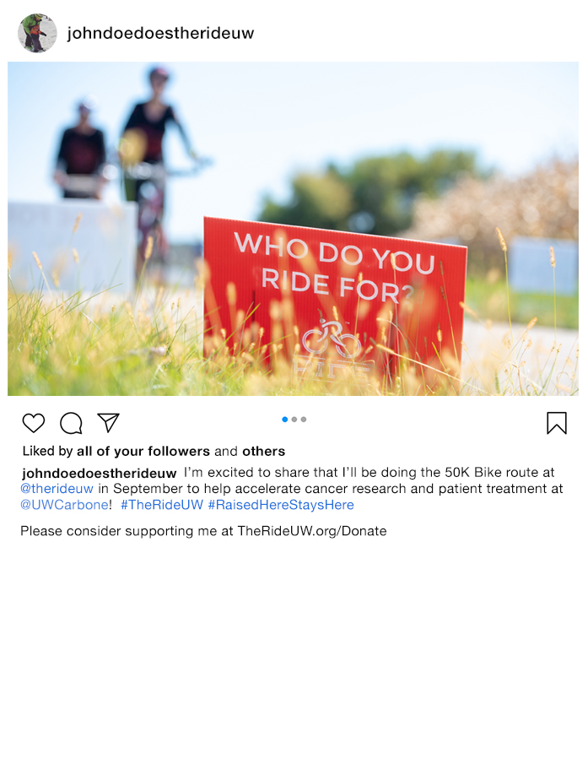
I’m excited to share that I’ll be doing the [5K, HALF-MARATHON, 25K, 50K, 100K, 100-MILE] [WALK, RUN, BIKE] route at @TheRideUW in September to help accelerate cancer research at patient treatments at @UWCarbone! #TheRideUW #RaiseHereStaysHere

Please consider supporting me at TheRideUW.org/Donate

[ADD PERSONAL IMAGE]

AT THE TIME OF REGISTRATION, SAMPLE 2
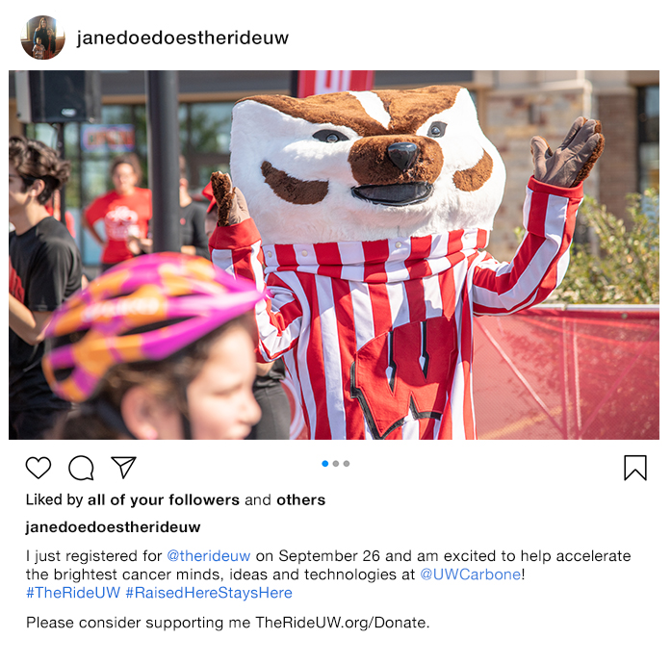
FUNDRAISING ASK #2

I just registered for @TheRideUW on September 26 and am excited to help accelerate the brightest cancer minds, ideas and technologies at @UWCarbone!
#TheRideUW #RaiseHereStaysHere

Please consider supporting at TheRideUW.org/Donate

[ADD PERSONAL IMAGE]

AT THE TIME OF REGISTRATION, SAMPLE 3
JOIN MY FUNDRAISING TEAM #1
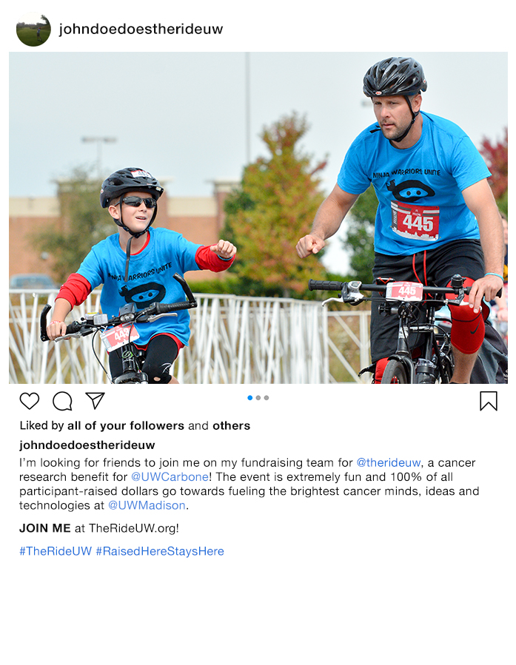
I’m looking for friends to join me on my fundraising team for @TheRideUW, a cancer research benefit for @UWCarbone! The event is extremely fun and 100% of all participant-raised dollars go towards fueling the brightest cancer minds, ideas and technologies at @UWMadison.

JOIN ME at TheRideUW.org!

#TheRideUW #RaisedHereStaysHere

[ADD PERSONAL IMAGE]

AT THE TIME OF REGISTRATION, SAMPLE 4
JOIN MY CORPORATE TEAM #1

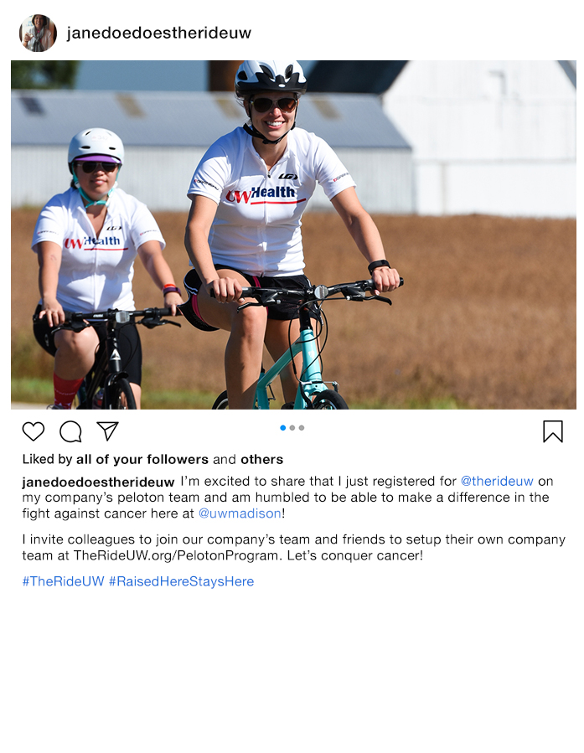
I’m excited to share that I just registered for @TheRideUW on my company’s peloton team and am humbled to be able to make a difference in the fight against cancer here at @UWMadison!

I invite colleagues to join our company’s team and friends to setup their own company team at TheRideUW.org/PelotonProgram. Let’s conquer cancer!

#TheRideUW #RaisedHereStaysHere

[ADD PERSONAL IMAGE]

INVITE OTHERS, SAMPLE 1
JOIN ME AT THE RIDE #1
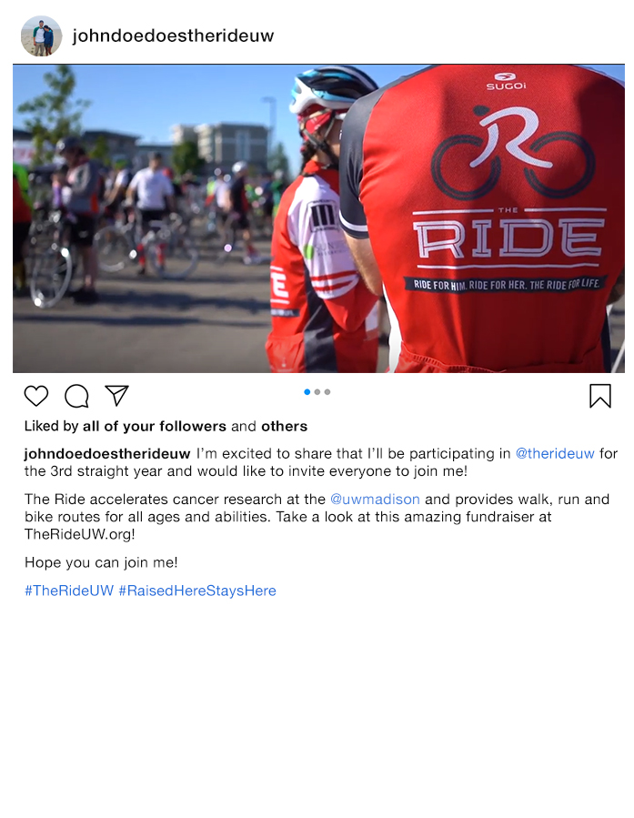
I’m excited to share that I’ll be participating in @TheRideUW for the [FIRST TIME? FOURTH STRAIGHT YEAR?] and would like to invite everyone to join me!

The Ride accelerates cancer research at @UWMadison and provides walk, run and bike routes for all ages and abilities. Take a look at this amazing fundraiser at TheRideUW.org

Hope you can join me!

#TheRideUW #RaisedHereStaysHere

[ADD PERSONAL IMAGE]

INVITE OTHERS, SAMPLE 2
JOIN ME AT THE RIDE #2
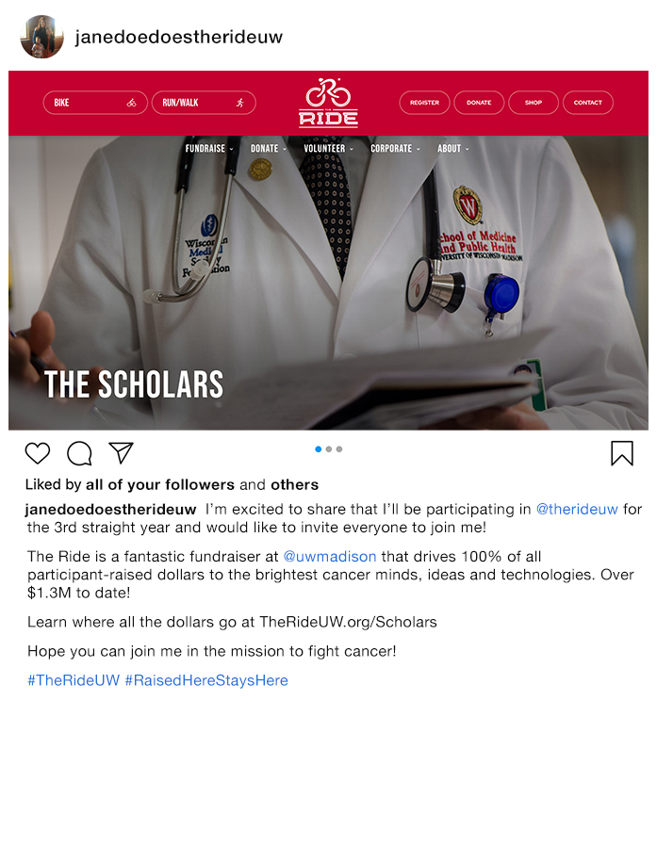
I’m excited to share that I’ll be participating in @TheRideUW for the [FIRST TIME? FOURTH STRAIGHT YEAR?] and would like to invite everyone to join me!

The Ride is a fantastic fundraiser at @UWMadison that drives 100% of all participant-raised dollars to the brightest cancer minds, ideas and technologies. Over $1.3M to date!

Learn where all the dollars go at TheRideUW.org/Scholars

Hope you can join me in the mission to fight cancer!

#TheRideUW #RaisedHereStaysHere

[ADD PERSONAL IMAGE]

